Experimental result of the Formula Electric Car Physical Parameters:

Torque Array Plots from Dyno Data

(Spring ‘16)



Zainab Hussein

3-24-2017

# Hypothesis

Theoretically, current has a linear relationship to torque when motor speed is held constant as in figure 1, while torque has a hyperbolic relationship to motor speed when current is constant in figure 2. Thus, experimental data should ideally show an array of relationships as shown in figure 1 and 21.

Figure 1 Current and torque relation at constant motor speed

Figure 2 Motor speed and torque relation with constant current

# Method

Raw data collected from the dynamometer was analyzed using Origin. The original data was extrapolated, specifically 1863 columns and 224 rows to form a matrix used to generate a contour 3D plot. Figure 3 shows current and torque relation when the contour plot is cut at constant values of motor speed. Figure 4 shows motor speed and torque relation when the contour plot is cut at constant values of current.

# Result

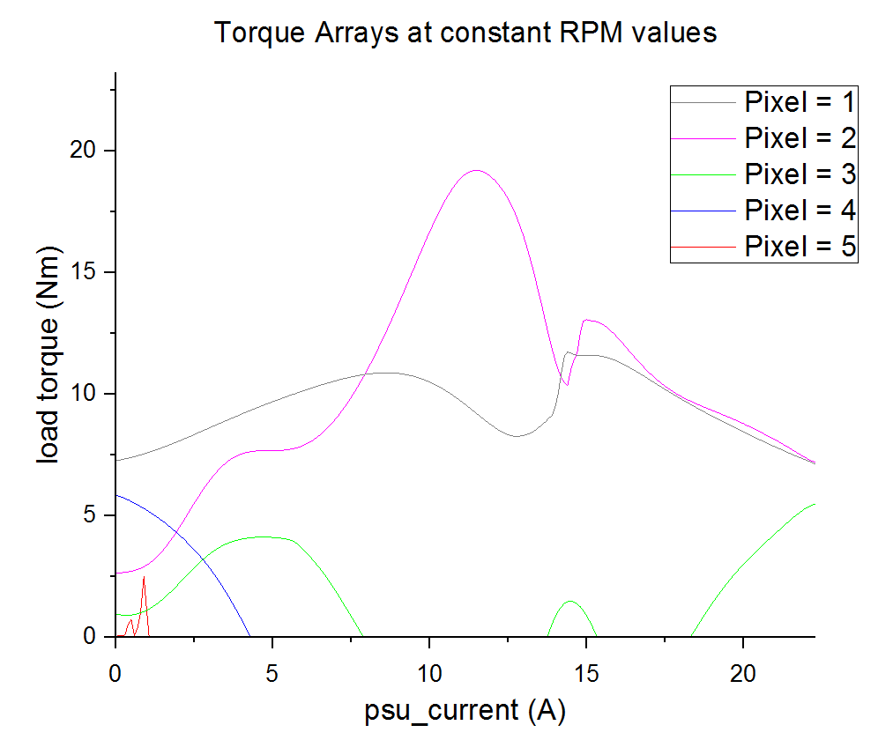

Figure Torque Arrays at constant RPM

## Table 1

|  |  |  |
| --- | --- | --- |
| Torque at Constant RPM values | | |
|  | Actual RPM (rad/s) | Approximate RPM (rad/s) |
| Pixel 1 | 8005 | 8000 |
| Pixel 2 | 6000 | 6000 |
| Pixel 3 | 4005 | 4000 |
| Pixel 4 | 2017 | 2000 |
| Pixel 5 | 12.57 | 0 |

Figure 32 shows more of a transient behavior than the expected linear relationship. The range of current is 0 – 22A, which may not be sufficient to characterize a motor and motor controller system that goes to a max of 200A.

A wider range of measurement would be the next step to realistically characterize the entire motor and motor controller system, and eliminate the suspicion of the current data depicting a transient behavior, rather than a steady state one.

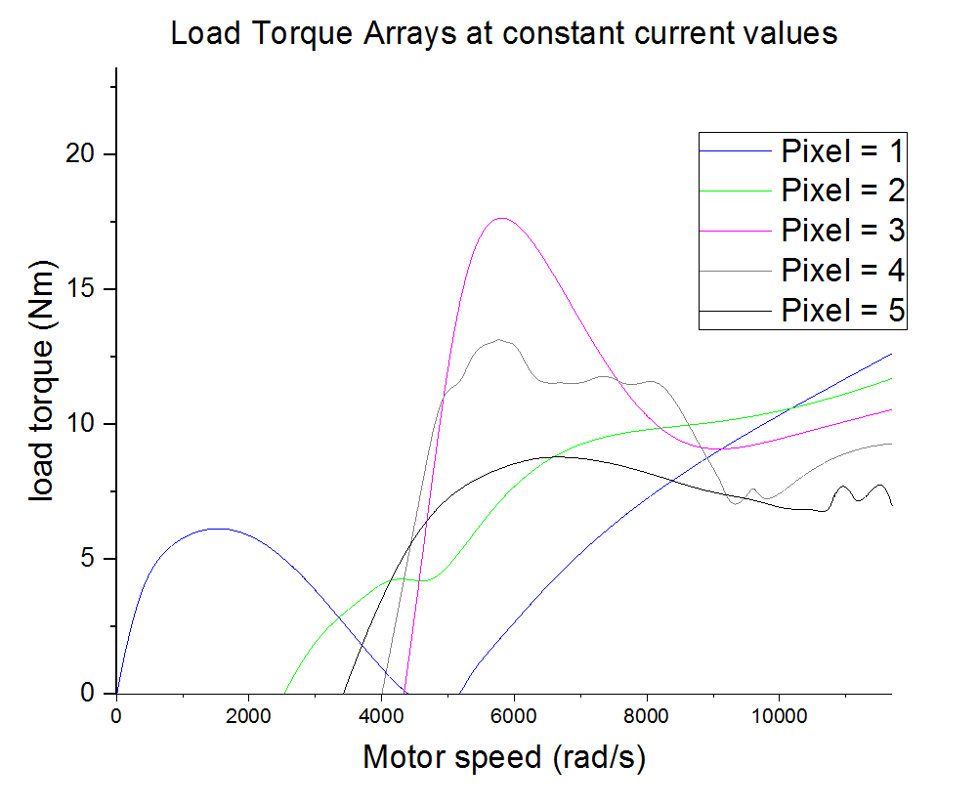

Figure 4 Torque arrays at constant Current

## Table 2

|  |  |  |
| --- | --- | --- |
| Torque at Constant Current values | | |
|  | Actual Current (A) | Approximate Current (A) |
| Pixel 1 | 0.01246 | 0 |
| Pixel 2 | 4.969 | 5 |
| Pixel 3 | 9.992 | 10 |
| Pixel 4 | 15.01 | 15 |
| Pixel 5 | 20.02 | 20 |

Figure 42 shows a motor speed array that is not depicting a hyperbolic relationship between motor speed and load torque. The range of current is 0 – 22A, which may not be sufficient to characterize a motor and motor controller system that goes to a max of 200A. Behavior under 1000 rad/s are transient as well.

A wider range of measurement would be the next step to realistically characterize the entire motor and motor controller system, and eliminate the suspicion of the current data depicting a transient behavior, rather than a steady state one.

# References:

1Theoretical relation of the formula Electric Car Physical Parameters of Load Torque, Supply Current and Motor Speed.

2Plotting 3D surfaces in Origin: <http://wiki.originlab.com/~originla/howto/index.php?title=Tutorial:3D_Plotting>

<http://www.originlab.com/index.aspx?go=Products/Origin/Graphing>